# Network Automation 8.7 (External Script Actions)

Network Automation 8.7 (External Script Actions) 1

Description 2

SoapUI 2

Updating the Devices Realm 3

External Script Actions 3

Custom action runtime parameters 4

Implementing 7

Upload the external action script. 7

Create Job 8

Add Job Action 8

Prompt for Span Selection 9

Submit and Execute Job 9

# 

## Description

The UpdateRealm script demonstrates how to update the realm associated with a device based on the device’s configuration file. This is useful for breaking devices out into distinct control groups.

### SoapUI

When working with Web Services it is highly recommended that you download SoapUI. Soap UI is a functional testing tool for API testing that supports various protocols.

<http://www.soapui.org/>

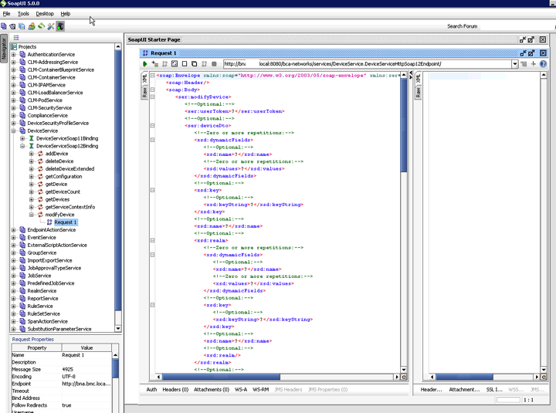

## Updating the Devices Realm

### External Script Actions

<https://docs.bmc.com/docs/display/public/bna87/Working+with+external+script+actions>

The XML file that defines the external script action used.

<?xml version="1.0" encoding="UTF-8" ?>

<deviceTypeMap xmlns:xsi="http://www.w3.org/2001/XMLSchema-instance">

<externalScriptDeclaration>

<name>Update Realm </name>

<guid>AE89A898-34A4-40D9-8B3C-207F6322CAC9</guid>

<groupName>Device Actions</groupName>

<classification>3</classification>

<browserExecutable>true</browserExecutable>

<spanSelection>true</spanSelection>

<scriptName>UpdateRealm.bat</scriptName>

<scriptArgs>

<scriptArg>

${file.startup.trusted}

</scriptArg>

<scriptArg>

${device.name}

</scriptArg>

<scriptArg>

${runtime.Search}

</scriptArg>

<scriptArg>

${runtime.Realm}

</scriptArg>

</scriptArgs>

<runtimeParameters>

<runtimeParameter>

<name>Search</name>

<prompt>Search String</prompt>

<type>text</type>

<required>true</required>

</runtimeParameter>

<runtimeParameter>

<name>Realm</name>

<prompt>Realm</prompt>

<type>text</type>

<required>true</required>

</runtimeParameter>

</runtimeParameters>

<deleteTemporaryFilesOnCompletion>false</deleteTemporaryFilesOnCompletion>

</externalScriptDeclaration>

</deviceTypeMap>

The external script action above uses the following parameters as script arguments.

<scriptArgs>

<scriptArg>

${file.startup.trusted}

</scriptArg>

<scriptArg>

${device.name}

</scriptArg>

<scriptArg>

${runtime.Search}

</scriptArg>

<scriptArg>

${runtime.Realm}

</scriptArg>

</scriptArgs>

* *${file.startup.trusted}* On detecting this substitution parameter, the trusted startup configuration of the device is stored in a temporary file, and the parameter is substituted with the temporary file name.
* *${device.name}* This parameter is substituted with the name of the device being processed.

### Custom action runtime parameters

<https://docs.bmc.com/docs/display/public/bna87/Understanding+custom+action+runtime+parameters>

* *${runtime.Search}* This defines a custom action runtime parameter. The parameter is substituted by the value entered during Job creation. This should contain the value we want to match against when processing the device’s configuration.

<runtimeParameter>

<name>Search</name>

<prompt>Search String</prompt>

<type>text</type>

<required>true</required>

</runtimeParameter>

* *${runtime.Realm}* This defines a custom action runtime parameter. The parameter is substituted by the value entered during Job creation. This should contain the Realm we want to update the device with if there is a match with the value contained in *${runtime.Search}.*

When processed the following actions occur.

1. Prompt for span selection.

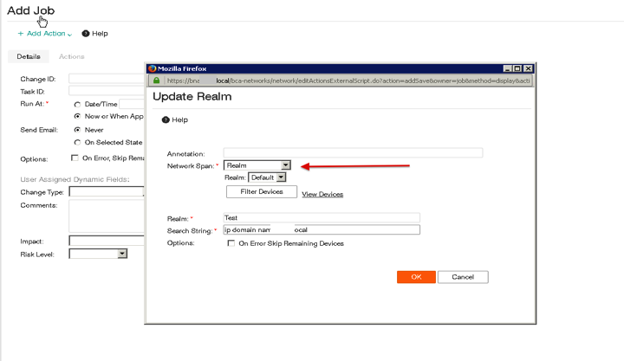

1. Prompt for runtime parameters.

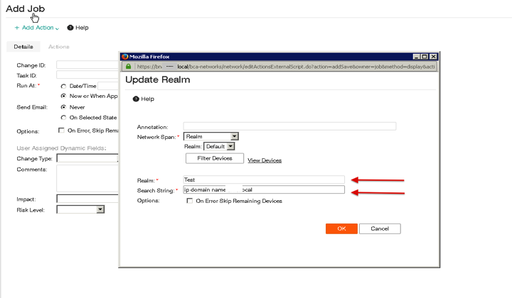

1. For each device in the selected span.
2. Resolve file substitution, device, and runtime parameters.
3. Execute UpdateRealm.bat for each device.

<scriptName>UpdateRealm.bat</scriptName>

The UpdateRealm.bat script calls the UpdateRealm.pl script with the parameters discussed above.

@ECHO OFF

UpdateRealm.pl -f %1 -d %2 -s %3 -r %4 -t yes

* -f Contains the path to the devices configuration.
* -d Contains the device name
* -s Contains the configuration search string
* -r Contains the realm we want to update the device to
* **-t (Optional)** This flag will create a trace file in the current directory from which the script is executed.

## Implementing

### Upload the external action script.

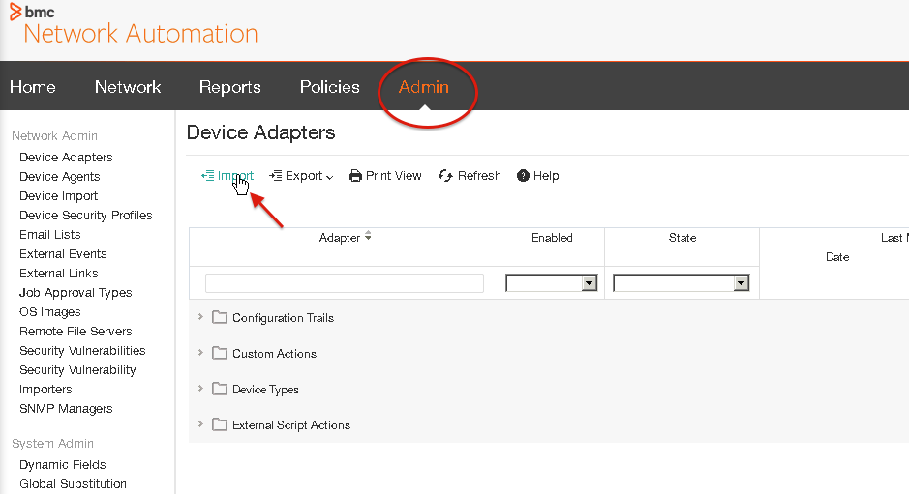

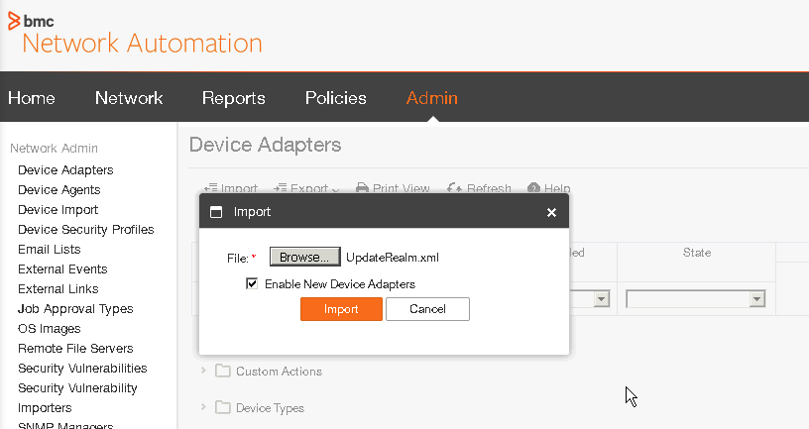

### Create Job

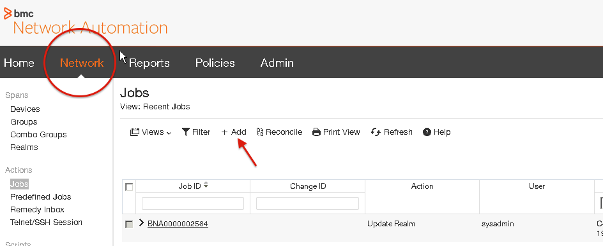

### Add Job Action

<groupName>Device Actions</groupName>

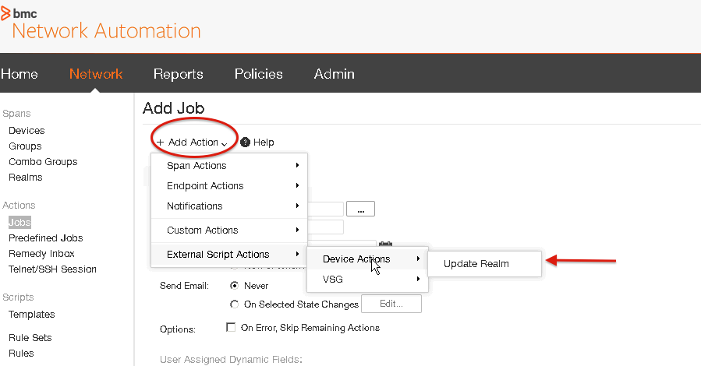

### Prompt for Span Selection

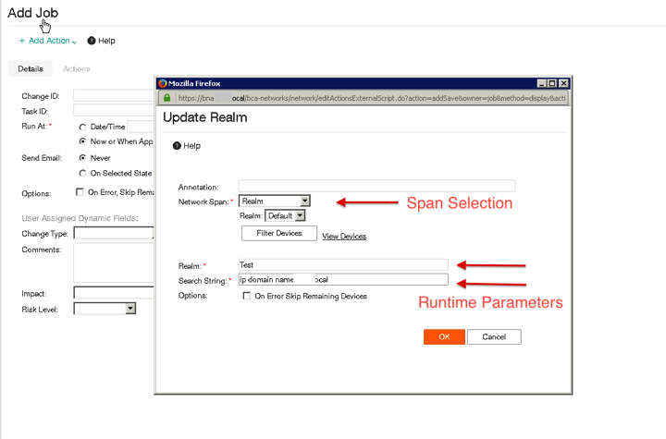

### Submit and Execute Job

